*Week 1:*

I made the layout of the Pacman maze by using file handling and pygame

0 in notepad … empty space in pygame

1 in notepad … wall (collide rect) in pygame

2 in notepad … score points (I don’t know the name) in pygame

3 in notepad … bigger score points (I don’t know the name) in pygame

A screenshot of a computer

Description generated with very high confidence

*Week 2:*

I made the movement of Pacman, the collision system of Pacman, as well as a score counter

-Pacman doesn’t stop moving unless collide with wall

-Didn’t use colour collision, instead I made the pacman’s 4 edges as coordinates to determine weather it hit a wall

-when pacman collide with a white dot, adds 1 to the score, when the score hits a specific number, level is considered as completed

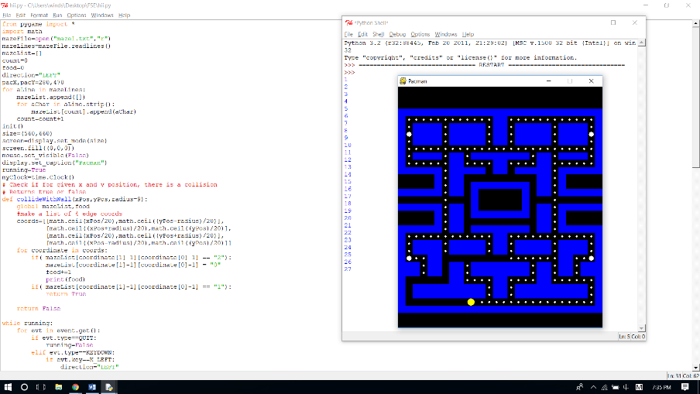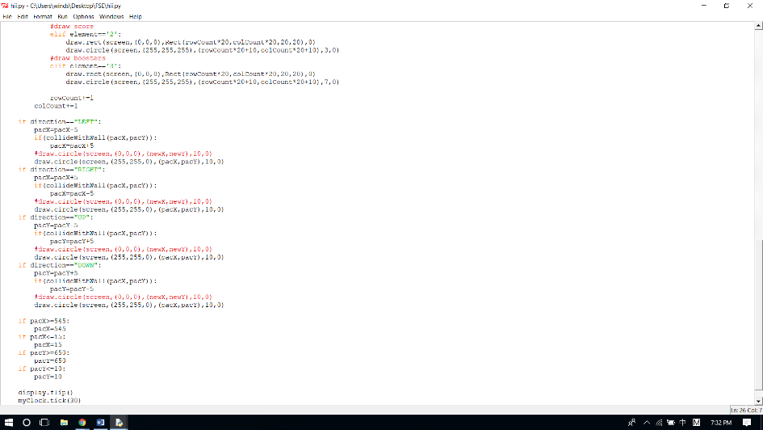

*Week 3:*

Added minor improvements:

-ready/level complete text

-score count and score text

-pacman lives

Pacman Collision System:

-when character wants to turn into a wall, it will stop the character from turning, and continue to move to the direction it was originally approaching

-key buffer (stores the key direction for 5 frames, if there is a turn within the 5 frames, it will register the turn. By implementing this, it will make the movement smoother and easier to operate)

*Week 4:*

Video

*Week 5:*

Pacman Collide with Enemy:

-if pacman collide within the enemy, the pacman will respawn at the original position. Each round gets 3 lives to respawn until

Level Completed/Failed Screen:

-screen involves options including next level/restart/quit (all functional by mouse click) also will display the score when died on level failed screen

Organized Code:

-organized some of the repeated if statements into functions and loops

*Week 6:*

-added start menu

-edited death screen and level completed screen

-added 2 different levels (3 levels in total)

-edited enemy spawn location

-edited some minor issues (ex. removed unused variables, organized some code)